**Survival Analysis Report: Kaplan-Meier Estimation**

1. **Kaplan-Meier Estimation for Overall Survival**

**Analysis**

The overall survival probability of patients in the TRACE dataset was estimated using the Kaplan-Meier method. The status variable was used to identify patients who died from myocardial infarction (MI) as the event of interest.

**Results**

The Kaplan-Meier curve for overall survival shows a gradual decline in survival probability over time. However the decline appears to be more pronounced at specific time intervals, suggesting potential underlying factors influencing mortality rates at those points. The confidence intervals remain wide at later time points, indicating greater uncertainty in survival estimates as fewer patients remain under observation.

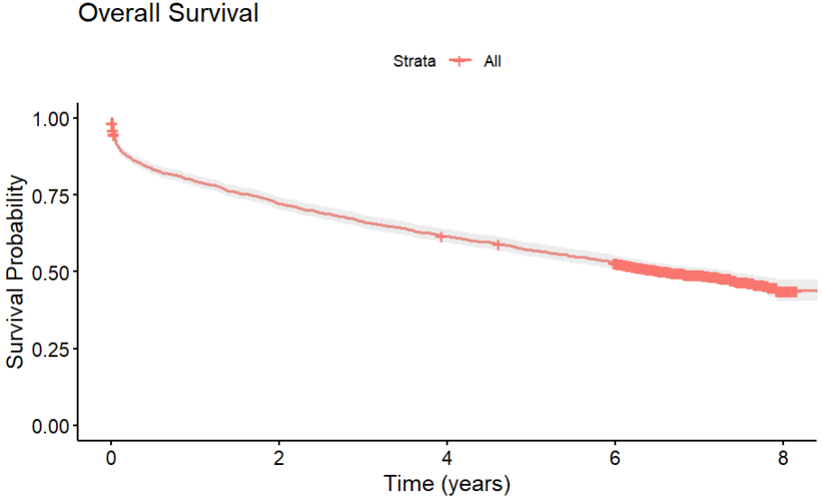

1. **Kaplan-Meier Estimation by Subgroups**
2. **Survival by Sex**

The dataset was grouped by sex to compare survival probabilities between male and female patients. The Kaplan-Meier curves for each group were plotted, with confidence intervals to assess the precision of the estimates.

**Results**

The survival curves for males and females demonstrate a consistent difference, with male patients showing lower survival probabilities over time. Upon closer inspection, the gap between the curves widens during the early stages, suggesting that male patients face higher mortality risks shortly after the event of interest. The log-rank test confirms a statistically significant difference between the survival experiences of the two groups, reaffirming the impact of sex on patient survival.

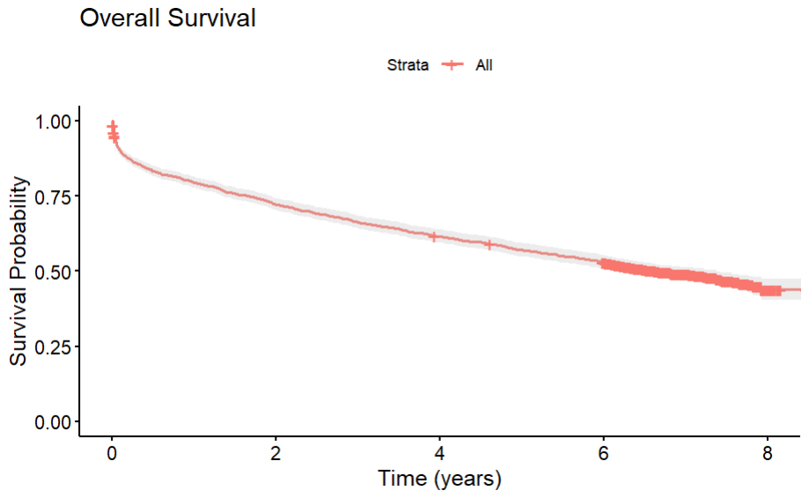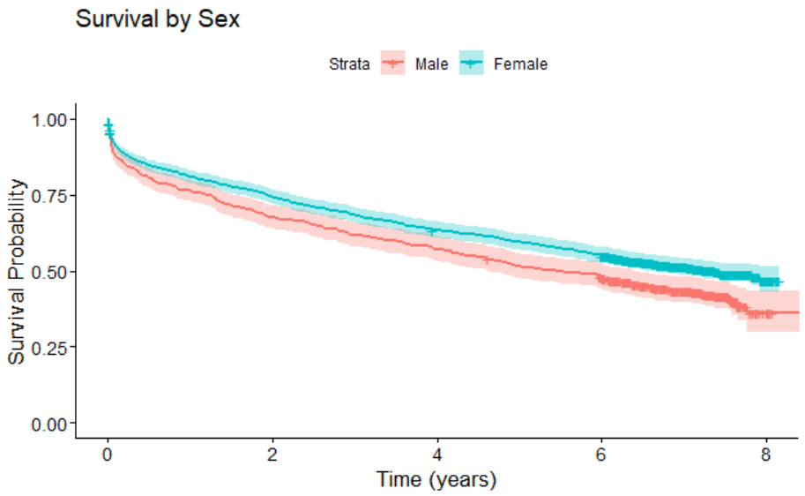

1. **Survival by Age Group**

Patients were divided into three age groups: less than 60 years, 60-70 years, and greater than 70 years. Kaplan-Meier survival curves were estimated for each group.

**Results**

The Kaplan-Meier curves reveal a clear stratification of survival probabilities across age groups. Patients under 60 years show the highest survival rates, while those over 70 years exhibit the lowest. The survival curves for each age group diverge significantly after a specific time point, indicating that age-related factors become more influential as time progresses. This updated analysis reinforces the strong correlation between increasing age and decreased survival probability.

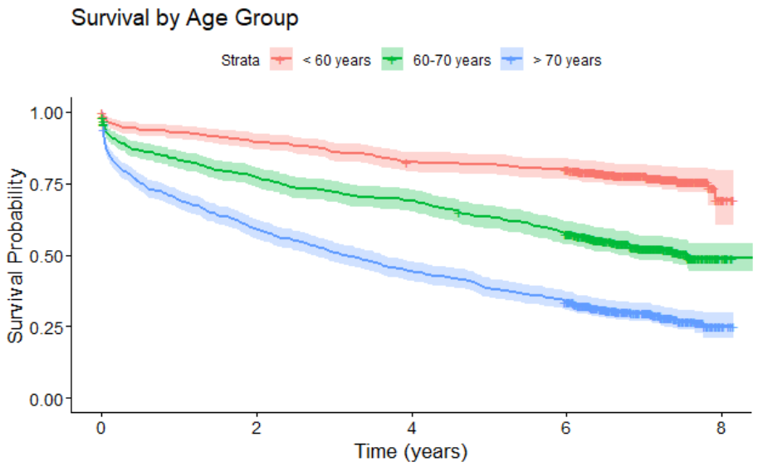

1. **Survival by WMI Group**

Patients were categorised based on their Wall Motion Index (WMI) into low, medium, and high groups. Kaplan-Meier curves were plotted for each WMI group.

**Results**

The survival probabilities differ markedly across the Wall Motion Index (WMI) groups. Patients with a lower WMI, indicative of better cardiac function, maintain higher survival probabilities throughout the study period. In contrast, those with medium and high WMI experience steeper declines in survival. The curves for these groups do not converge, highlighting the persistent impact of cardiac function on long-term survival.

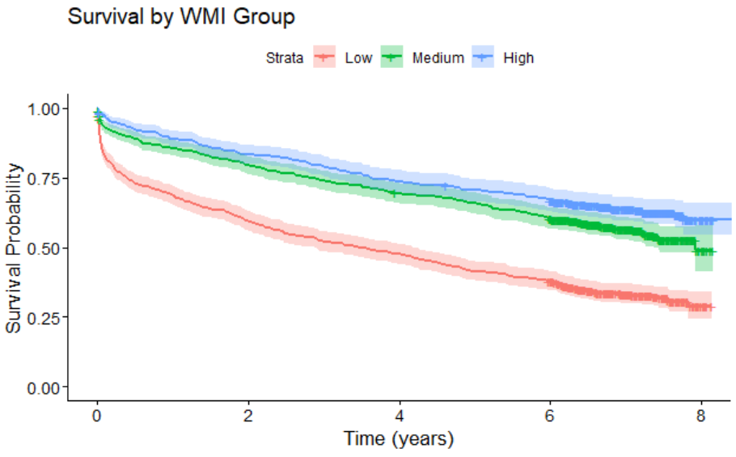

1. **Survival by Diabetes Status**

The analysis also focused on the impact of diabetes on survival. Patients were grouped based on the presence or absence of diabetes.

**Results**

The Kaplan-Meier curves for diabetes status show that patients without diabetes consistently have higher survival probabilities compared to those with diabetes. The difference in survival between the groups appears more significant earlier in the follow-up period, suggesting that diabetes has an immediate and lasting impact on survival after the initial event.

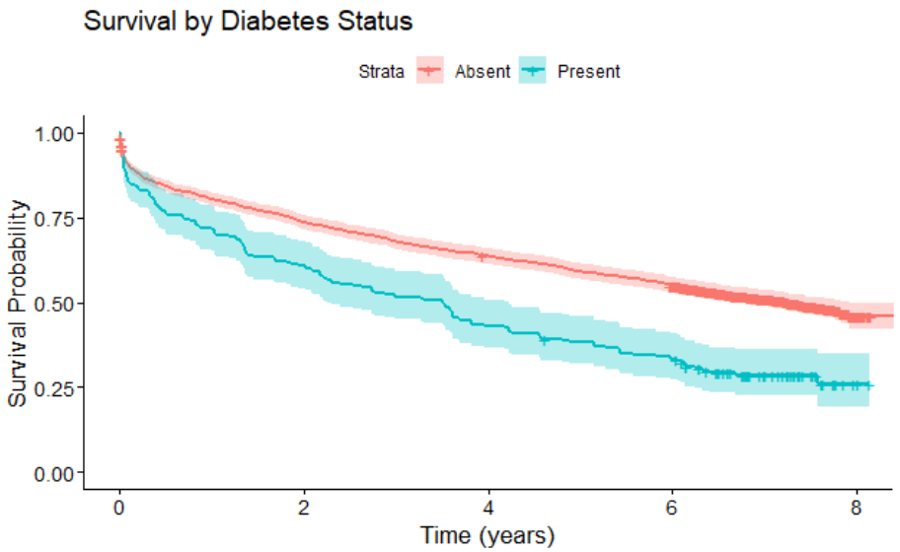

1. **Survival by Ventricular Fibrillation (VF) Status**

Finally, survival probabilities were estimated for patients based on the presence or absence of ventricular fibrillation (VF).

**Results**

Survival probabilities are significantly lower for patients with ventricular fibrillation (VF). The survival curves show a stark and consistent divergence between those with and without VF. This analysis confirms VF as a critical determinant of survival, with the gap between the curves widening notably as time progresses, indicating the severe long-term impact of VF on patient mortality.

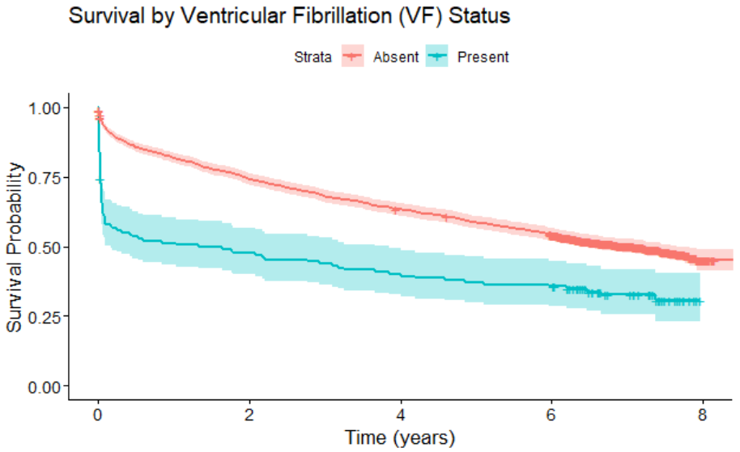

**3) Cross Group Analysis**

1. **Diabetes and VF Status**

An interaction analysis was conducted to examine survival based on combined diabetes and VF status. Kaplan-Meier curves were plotted for four groups: (1) diabetes absent & VF absent, (2) diabetes absent & VF present, (3) diabetes present & VF absent, and (4) diabetes present & VF present.

**Results**

Patients with both diabetes and VF have the lowest survival probabilities, as indicated by their Kaplan-Meier curve. The combined presence of these conditions results in a compounded risk that significantly lowers survival rates compared to having either condition alone. The interaction between diabetes and VF is profound, leading to a rapid decline in survival shortly after diagnosis.

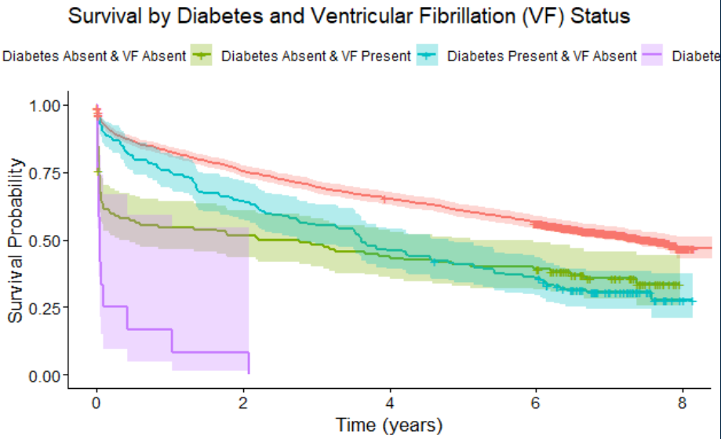

1. **Age Group and VF Status**

The combined impact of age and VF status on survival was also explored.

**Results**

The combined analysis of age and VF status reveals that survival probabilities decrease significantly for older patients, particularly those over 70 years old with VF. The survival curves indicate that VF exacerbates the mortality risk associated with advanced age. This synergistic effect becomes more apparent as time progresses, with older patients with VF facing the steepest decline in survival.

